Vihtavuori Load Data - 8 x 68 S
The 8×68mm S rebated rim bottlenecked centre fire rifle cartridge was developed in the 1930s by August Schüler of the August Schüler Waffenfabrik, Suhl, Germany as a magnum hunting cartridge that would just fit and function in standard-sized Mauser 98 bolt-action rifles. The 8 x 68 S was introduced to fit the very popular Mauser bolt-action rifles in the beginning of the 20th century with a cartridge adapted specifically for hunting. The 8 x 68 S is remarkably versatile, loaded lightly with the proper bullet type and weight it can be used on small game, while heavy loads and modern bullet constructions have been used successfully to hunt elephants. Official requirements on calibre size have made the 8 x 68 S unsuitable for Big Five hunting, 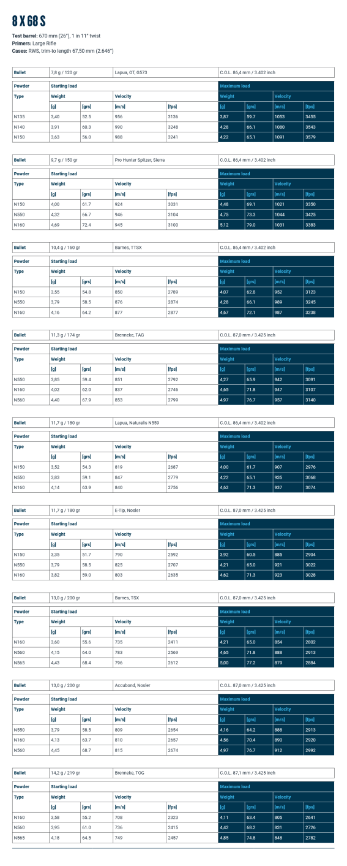wever.
As Reloading Solutions Limited has no control over improper storage, handling, loading or use of Vihtavuori powders after they have left our facility, we make no warranty of any kind, either expressed or implied, limited or full. We specifically disclaim all warranties of fitness for a particular purpose and merchantability. We specifically disclaim all liability for consequential damages of any kind whatsoever, whether or not due to seller’s negligence or based on strict product liability or principle of indemnity or contribution, Reloading Solutions Limited neither assumes nor authorises any person to assume for it any liability in connection with the use of this product.
